**CURRENCY CONVERTER**

1. **Introduction**

This Currency Converter is designed to convert entered numbers from one system/unit to other system/unit and it is also capable of handling all types of exceptions.

Module Used **–:**

Tkinter()- It is a standard Python interface to the Tk GUI toolkit shipped with Python. Python with tkinter outputs the fastest and easiest way to create the GUI applications.

Also, the design of this system is pretty simple so that the user won’t get any difficulties while working on it.

1. **Working**

* **Import libraries:** For this project based on Python, we are using the tkinter library. So we need to import the library.

from tkinter import *  
from tkinter import ttk

* **Set gui frame geometry and title:**

converter = Tk()  
converter.geometry("600x400")  
converter.title("Currency Converter")

* **Create OPTIONS dict:**

OPTIONS = {  
 "Australian Dollar" : 49.10,  
 "Brazilian Real":17.30,  
 "British Pound":90.92,  
 "Bulgarian Lev":39.8,  
 "Chinese Yuan":10.29,  
 "Euro":77.85,  
 "HongKong Dollar":8.83,  
 "Indonesian Rupiah":0.004864,  
 "Japanese Yen":0.628,  
 "Pakistani Rupee":0.49,  
 "Srilankan Rupee":0.39,  
 "Swiss Franc":69.62,  
 "US Dollar":69.32  
 }

* **ok() method:** This will return the converted amount

def ok():  
 price = rupees.get()  
 answer = variable.get()  
 DICT = OPTIONS.get(answer,None)  
 converted = float(DICT)*float(price)  
 result.delete(1.0,END)  
 result.insert(INSERT,"Price In ",INSERT,answer,INSERT,"=",  
 INSERT,converted)

* **Created a UI for currency converter:** This code will create a frame. One by one we willl add info in the code and below frame will be visible.

appName = Label(converter,text = "Currency",  
 font = ("arial",25,"bold","underline"),fg = "dark red")  
appName.grid(row=0,column = 0,padx = 10)  
appName = Label(converter,text = "Converter",  
 font = ("arial",25,"bold","underline"),fg = "dark blue")  
appName .grid(row = 0,column = 2, ipadx = 10)  
result = Text(converter,height = 5 ,width = 50 ,font = ("arial",10,"bold"),bd = 5)  
result.grid(row=1,columnspan = 10)  
  
india = Label(converter,text = "Indian Rupees:",  
 font = ("arial",10,"bold"),fg="red")  
india.grid(row = 2,column=0)  
rupees = Entry(converter,font = ("callibri",20))  
rupees.grid(row = 2,column = 1)  
choice = Label(converter,text = "Choose Country:",  
 font = ("arial",10,"bold"),fg = "red")  
choice.grid(row = 3,column=0)  
variable = StringVar(converter)  
variable.set(None)  
option = OptionMenu(converter,variable,*OPTIONS)  
option.grid(row = 3 ,column = 1,sticky = "ew")  
button = Button(converter,text="Convert",fg ="green",  
 font = ("calibri",20),bg = "powder blue",command=ok)  
button.grid(row=3,column=2)

mainloop()

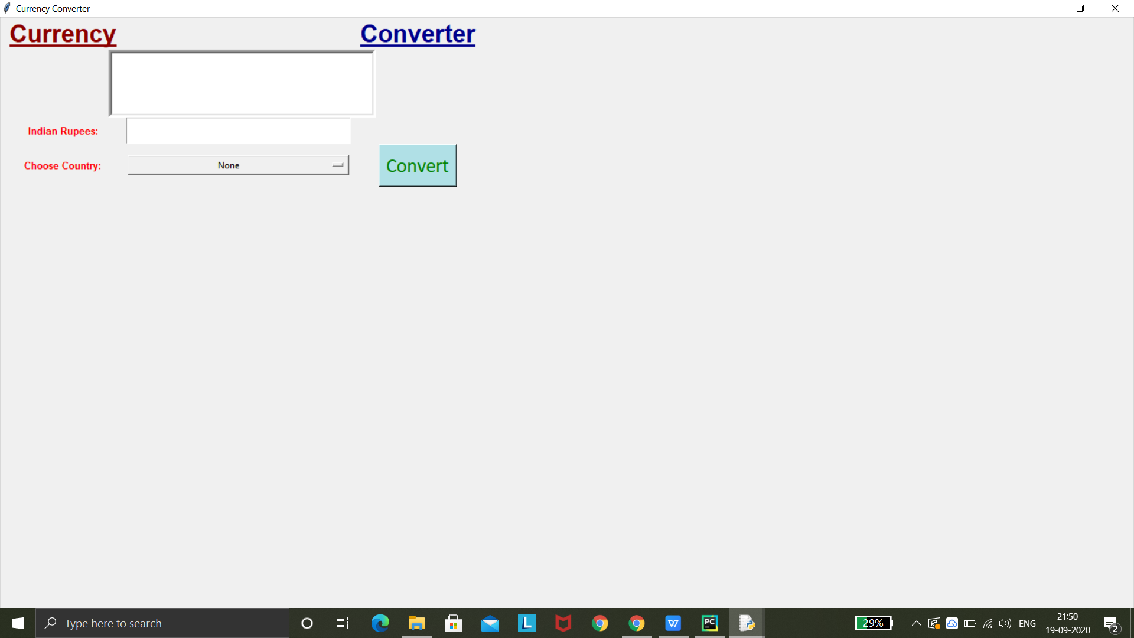

1. **Requirement**

* **Hardware Requirement :**

● RAM :64 MB

● Hard Disk:2.1 GB

* **Software Requirement :**
* Python3 idle

1. **Uses**

Currency converters usually display a value that is not biased towards buying or selling. This is useful when:

* Estimating the value of goods or services
* Basic accounting and invoicing
* Preparing financial plans and reports

1. **Future scope**

Currency converters aim to maintain real-time information on current market or bank exchange rates, so that the calculated result changes whenever the value of either of the component currencies does. They do so by connecting to a [database](https://en.wikipedia.org/wiki/Database" \o "Database) of current currency exchange rates.